**Naming Chemical Compounds Worksheet**

Name the following *ionic* compounds:

1) NaBr __________________________________________

2) CaO __________________________________________

3) Li2S __________________________________________

4) MgBr2 __________________________________________

5) Be(OH)2 __________________________________________

Write the formulas for the following *ionic* compounds:

6) potassium iodide __________________________________________

7) magnesium oxide __________________________________________

8) aluminum chloride __________________________________________

9) sodium nitrate __________________________________________

10) calcium carbonate __________________________________________

11) lithium sulfate __________________________________________

12) beryllium phosphide __________________________________________

13) magnesium hydroxide _________________________________________

14) sodium phosphate __________________________________________

15) aluminum carbonate __________________________________________

16) calcium chloride __________________________________________

17) sodium cyanide __________________________________________

18) aluminum oxide __________________________________________

19) magnesium acetate __________________________________________

20) ammonium chloride __________________________________________

Write the names of the following *covalent* compounds:

21) SO3 __________________________________________

22) N2S __________________________________________

23) PH3 __________________________________________

24) BF3 __________________________________________

25) P2Br4 __________________________________________

26) CO __________________________________________

27) SiO2 __________________________________________

28) SF6 __________________________________________

29) NH3 __________________________________________

30) NO2 __________________________________________

Write the formulas of the following *covalent* compounds:

31) nitrogen trichloride __________________________________________

32) boron carbide __________________________________________

33) dinitrogen trioxide __________________________________________

34) phosphorus pentafluoride ______________________________________

35) methane __________________________________________

36) sulfur dibromide __________________________________________

37) diboron tetrahydride __________________________________________

38) oxygen difluoride __________________________________________

39) carbon disulfide __________________________________________

40) nitrogen monoxide __________________________________________

**Naming Chemical Compounds - Answers**

Name the following *ionic* compounds:

1) NaBr **sodium bromide**

2) CaO **calcium oxide**

3) Li2S **lithium sulfide**

4) MgBr2 **magnesium bromide**

5) Be(OH)2 **beryllium hydroxide**

Write the formulas for the following *ionic* compounds:

6) potassium iodide **KI**

7) magnesium oxide **MgO**

8) aluminum chloride **AlCl3**

9) sodium nitrate **NaNO3**

10) calcium carbonate **CaCO3**

11) lithium sulfate **Li2SO4­**

12) beryllium phosphide **Be3P2**

13) magnesium hydroxide **Mg(OH)2**

14) sodium phosphate **Na3PO4**

15) aluminum carbonate **Al2(CO3)3**

16) calcium chloride **CaCl2**

17) sodium cyanide **NaCN**

18) aluminum oxide **Al2O3**

19) magnesium acetate **Mg(C2H3O2)2**

20) ammonium chloride **NH4Cl**

Write the names of the following *covalent* compounds:

21) SO3 **sulfur trioxide**

22) N2S **dinitrogen sulfide**

23) PH3 **phosphorus trihydride**

24) BF3 **boron trifluoride**

25) P2Br4  **diphosphorus tetrabromide**

26) CO **carbon monoxide**

27) SiO2 **silicon dioxide**

28) SF6 **sulfur hexafluoride**

29) NH3 **ammonia**

30) NO2 **nitrogen dioxide**

Write the formulas of the following *covalent* compounds:

31) nitrogen trichloride **NCl3**

32) boron carbide **BC**

33) dinitrogen trioxide **N2O3**

34) phosphorus pentafluoride **PF5**

35) methane **CH4**

36) sulfur dibromide **SBr2**

37) diboron tetrahydride **B2H4**

38) oxygen difluoride **OF2**

39) carbon disulfide **CS2**

40) nitrogen monoxide **NO**

**EMPIRICAL FORMULA WORKSHEET**

Name _____________________________ Date _________________________ Period ______

1. What is the empirical formula for a compound which contains 0.0134 g of iron, 0.00769 g of sulfur and 0.0115 g of oxygen?

2. Find the empirical formula for a compound which contains 32.8% chromium and 67.2% chlorine.

3. NAME the compound which contains 0.463 g Tl (#81), 0.0544 g of carbon, 0.00685 g of hydrogen and 0.0725 g oxygen by finding its empirical formula.

4. What is the empirical formula for a compound which contains 67.1% zinc and the rest is oxygen?

5. Barry Um has a sample of a compound which weighs 200.0 grams and contains only carbon, hydrogen, oxygen and nitrogen. By analysis, he finds that it contains 97.56 grams of carbon, 4.878 g of hydrogen, 52.03 g of oxygen and 45.53 g of nitrogen. Find its empirical formula.

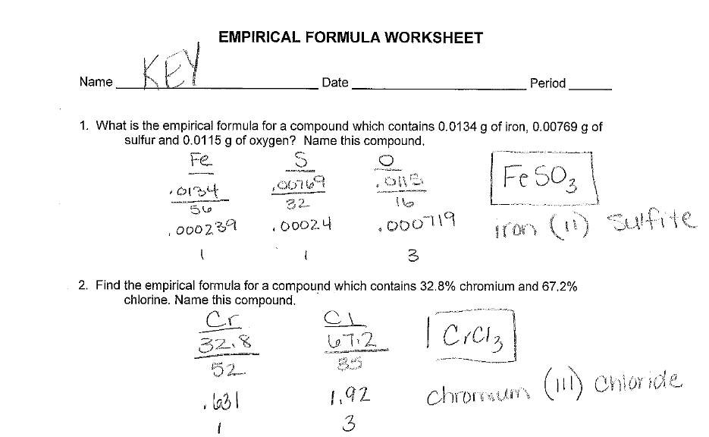

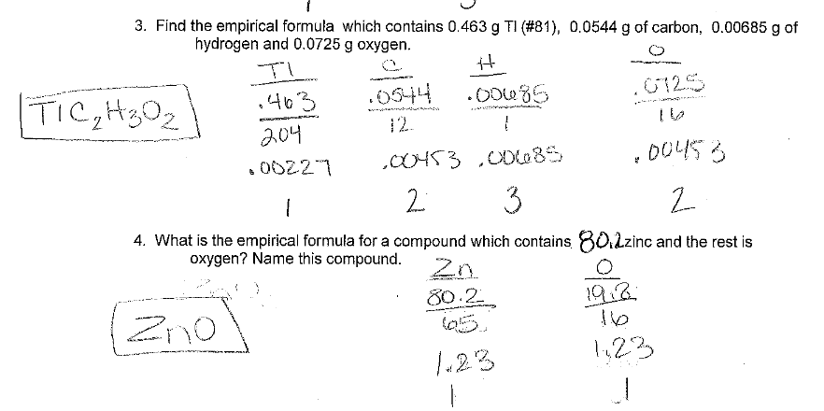

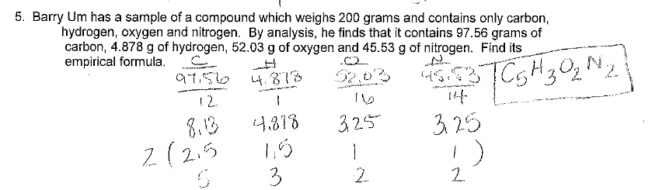

Balancing Equations Worksheets with answers:

Equations with symbols: <http://myweb.astate.edu/mdraganj/BalanceEqn.html>

Equations with naming:

http://www.pascack.org/cms/lib5/NJ01000238/Centricity/Domain/485/13%20cp%20additional%20word%20and%20balancing%20with%20key.pdf